MUNI UNIVERSITY
WEB APPLICATION DEVELOPMENT
MUGARRA TREVOR 2601202191
kweziMugarra-Trevor/itm1131-portfolio
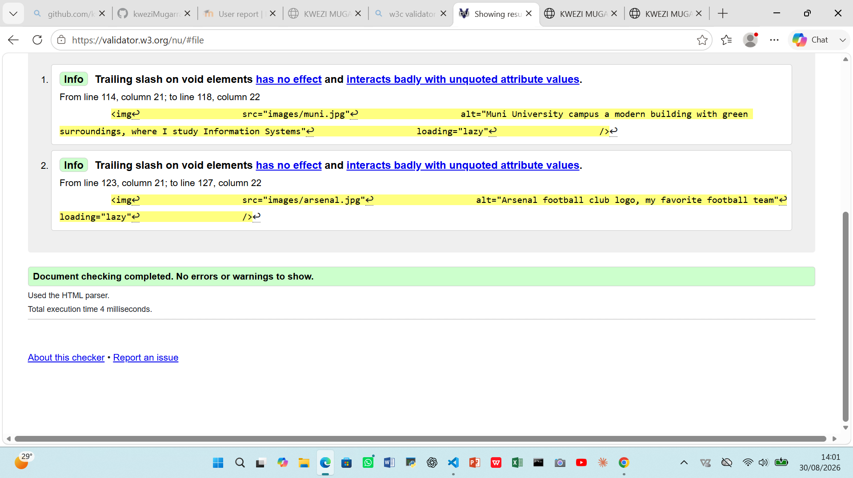
The most challenging part was figuring out how to apply CSS but I was to get directives from the ai assistant Dr. Adongah told us to use.
I learnt how websites are designed using CSS suchas the Muni university web site.
If I got stuck next time, I would simply consult my ai assisitant.
